**WIRED**

**IQ Air Atem X**

**Rating: 9/10**

***Premium looks. Easy to transport around my apartment. Incredibly quiet. The best thing if you can’t or don’t want to invest in an HVAC.***

“Want to come over and see my new air purifier?” I texted my friend. He immediately told me the [Atem X](https://www.iqair.com/air-purifiers/atem-x), IQAir’s latest consumer air purifier, with its large, minimalist, circular shape, had high-end [Bang & Olufsen speaker](https://www.wired.com/review/review-bang-and-olufsen-beosound-a5/) energy.

IQAir has been in the air game for over 50 years. One researcher told me they are the Rolls-Royce of air purifiers. They even come with papers, like a purebred dog. Each one leaves the factory in Germany with a certificate of proof of passing the test for ultrafine particle removal and decibel check while running at low, medium, and high. It also includes a signature *and* an embossed stamp that lets me know that the air purifier works.

My tester, which is the hyperHEPA version with high-efficiency particulate air filters, passed with flying colors and outperformed its advertised cleaning abilities. Unfortunately, all this comes with a $$$ price tag. The Atem X is definitely a long-term investment.

**If Looks Could Kill**

The Atem X has futuristic looks that would fit right into Stanley Kubrick’s classic *2001: A Space Odyssey*. It’s a white circle that stands upright, with a diameter of 25 inches. It snaps into its custom-fit dolly that disappears in its design. Its black faux leather strap on the back makes an easy handle to roll the Atem X from room to room. The power cord slips into a circular hidden groove in the back.

Imagine the Atem X as a large white tire from a flying car. The air circulates through the 10-inch wide grille, where the treads would be. This feature enables the purifier to sit flush against a wall or sofa. Unlike so many air cleaners, you don’t have to strategically position it in the center of a room.

**Smart**

It has a proprietary app that shows the air quality index average for the United States, along with the very important particulate matter (PM) reading. Particulate matter is not the dust you see suspended in a sunbeam. These particles have a diameter of 2.5 micrometers and are usually invisible to the naked eye. This is the [measurement I watch](https://www.wired.com/story/the-quest-for-clean-air/).

These particles pass into the deepest parts of our lungs and seep into our bloodstream and can cause a host of health problems, including heart attacks. It’s an oft-cited statistic that the average American spends an estimated 90 percent of their life indoors. Everything from bad outdoor air, cooking with a gas stove, and construction can affect it.

Like every consumer air monitor I’ve worked with, there is also a carbon dioxide reading, even though most air purifiers, including the Atem X, are unable to remove it. Carbon dioxide is what humans breathe out. While at very high levels it replaces oxygen and can be deadly, it’s not to be confused with the more lethal carbon monoxide. Like most New York City dwellings, mine has an alarm for that one. The CO2 reading is informational, like the app’s readings for temperature and humidity.

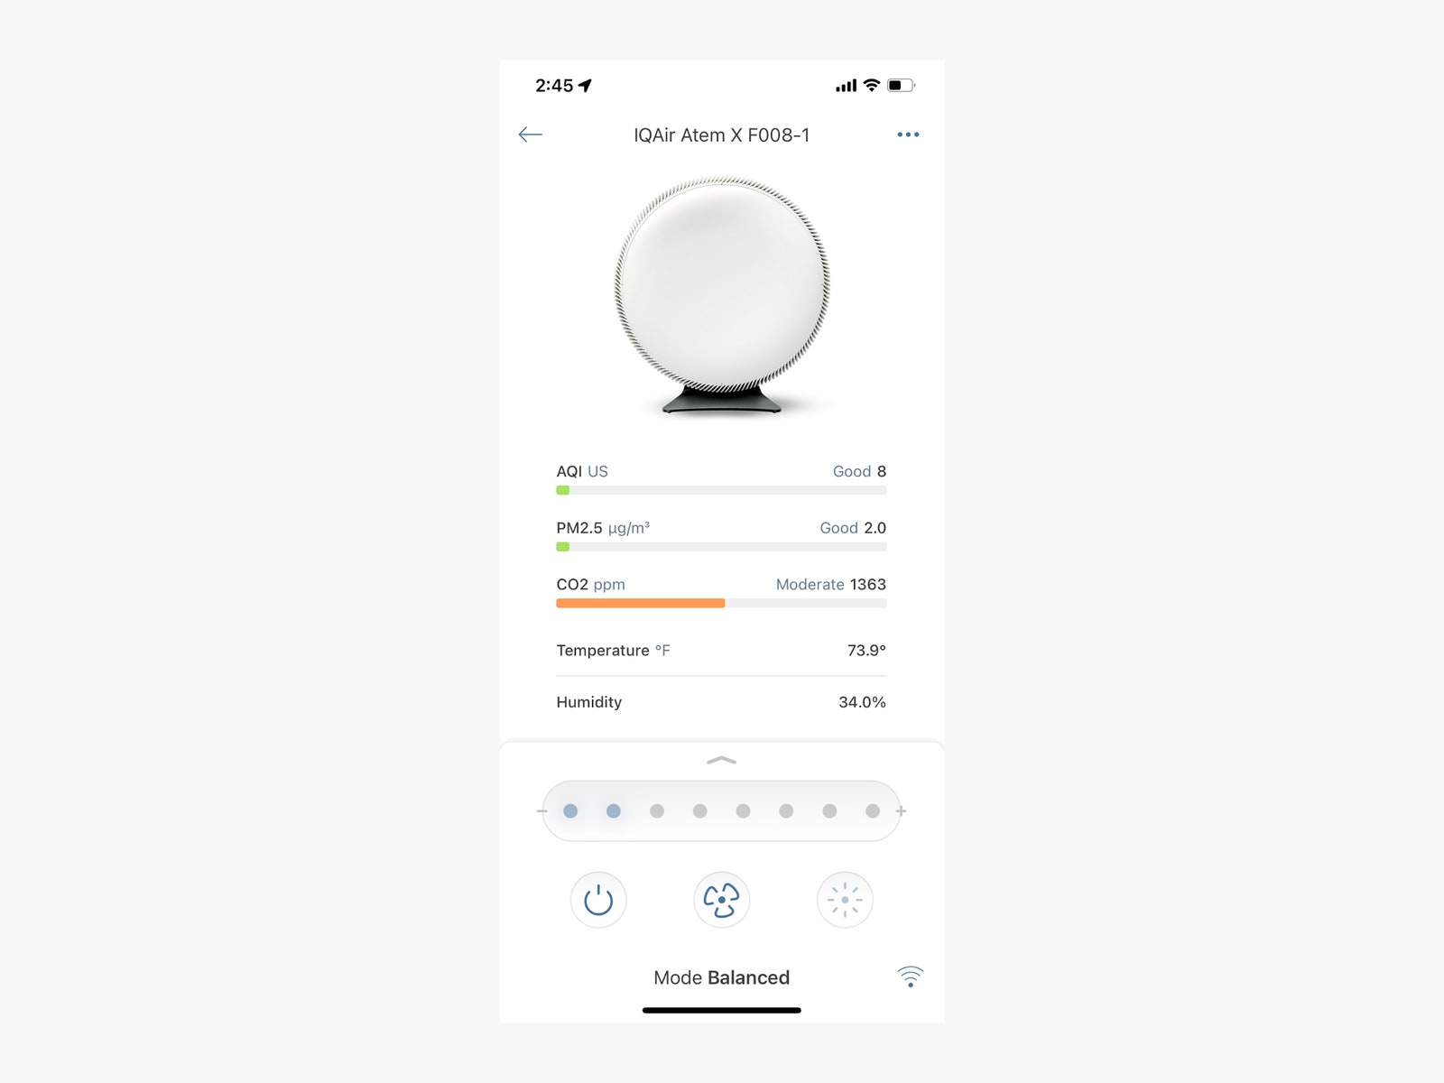

Photograph: Lisa Wood Shapiro

**IQ Air Atem X**

There are eight settings on the purifier that control the fan speed, or the rate of room clearing. The lowest setting is 1 and the highest is 8, meaning it will exchange or clean the room’s air at a faster rate; 8 is also the loudest setting. It can exchange the air in a 1,600-square-foot room twice in a single hour at its highest setting.

The Atem X also has smart control that gives the user agency over bespoke settings. For example, there are presets such that even if the air quality needs a solid cleaning, you can limit the purifier to keep it quiet—think baby nursery.

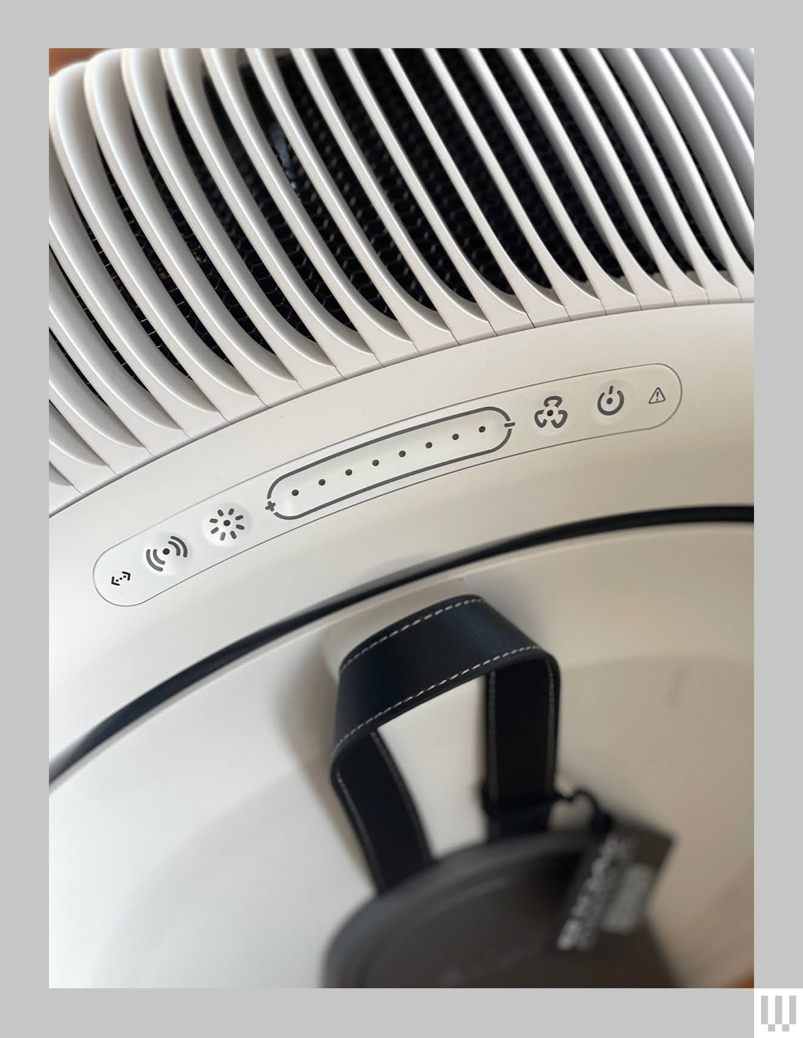

Photograph: Lisa Wood Shapiro

As for sound, it’s the most powerful and quietest air purifier I’ve tested. The maximum setting has a published ultrafine particle removal rate of 650 cubic meters per hour. (This is the measure of how fast and effectively an air purifier removes dust.)

According to my certificate of testing, at its highest setting the Atem X maxes out at 63 decibels, which is slightly higher than conversational speech in a restaurant, or from an air conditioner. At half that fan speed, the Atem X effectively cleans at a rate of 326 m3/h, well above its published rate of 250. It's also one decibel above a bird call at 45 dB. It’s barely noticeable. Several times I put my hand over the grille to feel for airflow. I wasn’t sure whether it was on.

**An HVAC Replacement**

While it’s true that my 135-year-old Brooklyn apartment is not the Berkeley Laboratory, it is the perfect location to test a consumer air cleaner. Aside from my two cats and a dog, there’s my close proximity to the Brooklyn Queens Expressway, a constant source of gasoline fumes that produce the cancer-causing [volatile organic compound benzene](https://www.cancer.gov/about-cancer/causes-prevention/risk/substances/benzene) as well as particulate matter.

My apartment also has vintage steam radiators. That viral [tweet](https://twitter.com/freedlander/status/1470920506803200010?lang=en), “The hottest summer I ever spent was a winter in a New York City apartment,” is true. That’s by design. The steam radiator system was intended to keep the apartment warm when you open the windows for airflow. Fresh air is healthy … on good air days, at least.

Like many of my neighbors apartments, mine won’t be retrofitted with an HVAC system complete with MERV filters to clean my air anytime soon. What happens when the air outside is toxic? I rely on portable air cleaners, especially at times like last spring, when [New York City turned orange](https://www.cnn.com/us/live-news/us-air-quality-canadian-wildfires-06-07-23/index.html) with heavy PM 2.5 from wildfires in Canada. At one point that day, New York had the worst air quality on Earth, with an index of 218. For context, Mumbai has the worst air as I’m writing this at 182. New York mayor Eric Adams [said out loud](https://twitter.com/therecount/status/1666467673025159168?lang=en) what we were all thinking that day: “I went outdoors and basically said, you know, What the hell is this?”

The fact that it’s quiet—rustling-leaves quiet—on its lower settings makes the Atem X an ideal investment for those without a central HVAC system with MERV filters, which are those pleated 1-inch-thick square filters that fit into a furnace or central air system. (MERV filters can also cover a box fan to make an inexpensive [DIY air purifier](https://www.wired.com/story/could-a-janky-jury-rigged-air-purifier-help-fight-covid-19/).)

**What doesn’t the Atem X do?**

Unlike IQAir’s GC Series, the Atem X doesn’t have a carbon filter and cannot clear the air of odor, gases, or volatile organic compounds, like benzene. The Atem X uses a hyperHEPA filter, which captures all the tiny but potentially deadly stuff, like viruses such as Covid-19, bacteria, and PM 2.5.

It’s been over four years since the world went into lockdown and indoor air quality became a main character. In a few short decades, we went from a society that smoked on airplanes to wearing KN95 masks in business class and coach. The minimalist white disc that IQAir says is “made in Germany with love” might signal a new way to think about air filters, a statement piece that brings the room together in a burning world. Even with the Atem X’s price tag, I would buy one. It’s playing the long game, a well-made handsome air filter made to go the distance.